1.write program for date picker

Source code:

<html>

<body>

<h1>Show a Date Control</h1>

<form action="/action_page.php">

<label for="birthday">Birthday:</label>

<input type="date" id="birthday" name="birthday">

<input type="submit">

</form>

</body>

</html>

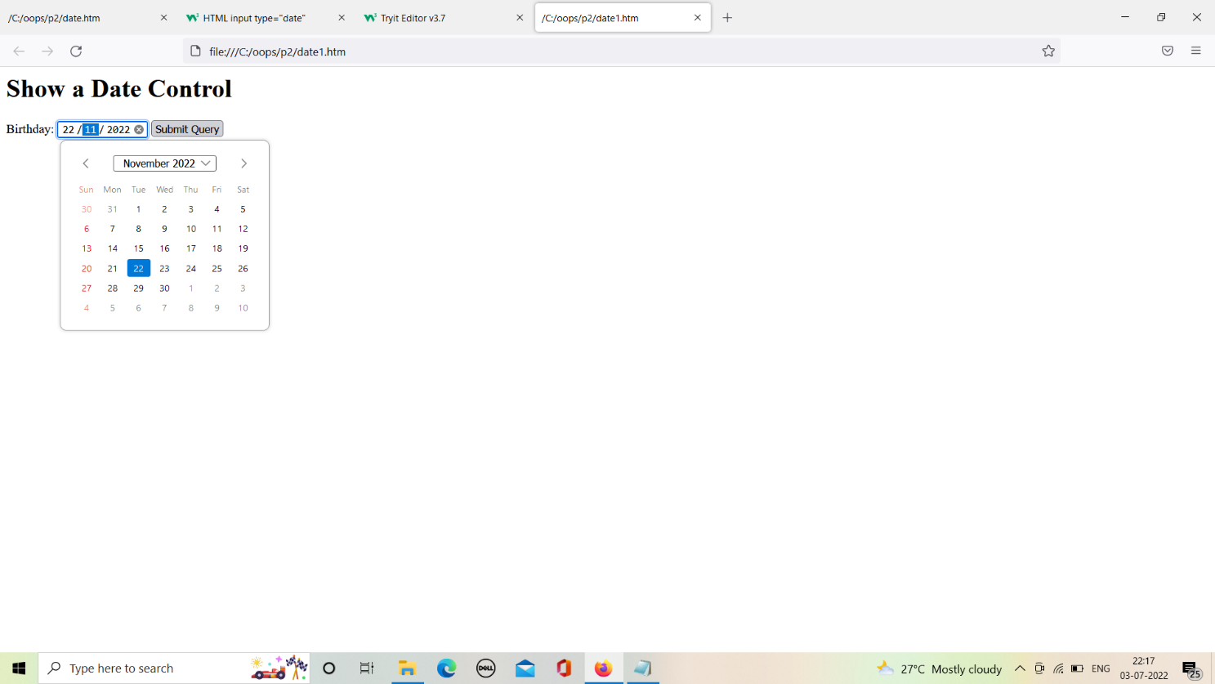

2.write program for color picker.

Source code:

<html>

<head>

</head>

<body>

<center>

<br><br><br><br>

<label for="colorpicker">Color Picker:</label>

<input type="color" id="colorpicker" value="#0000ff">

</center>

</body>

</html>

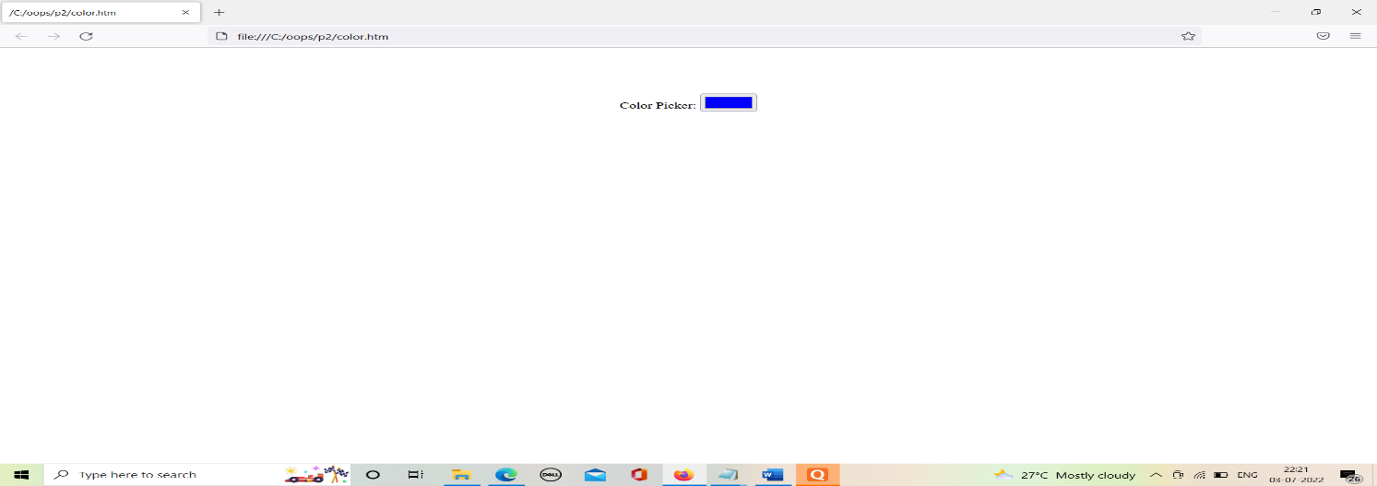

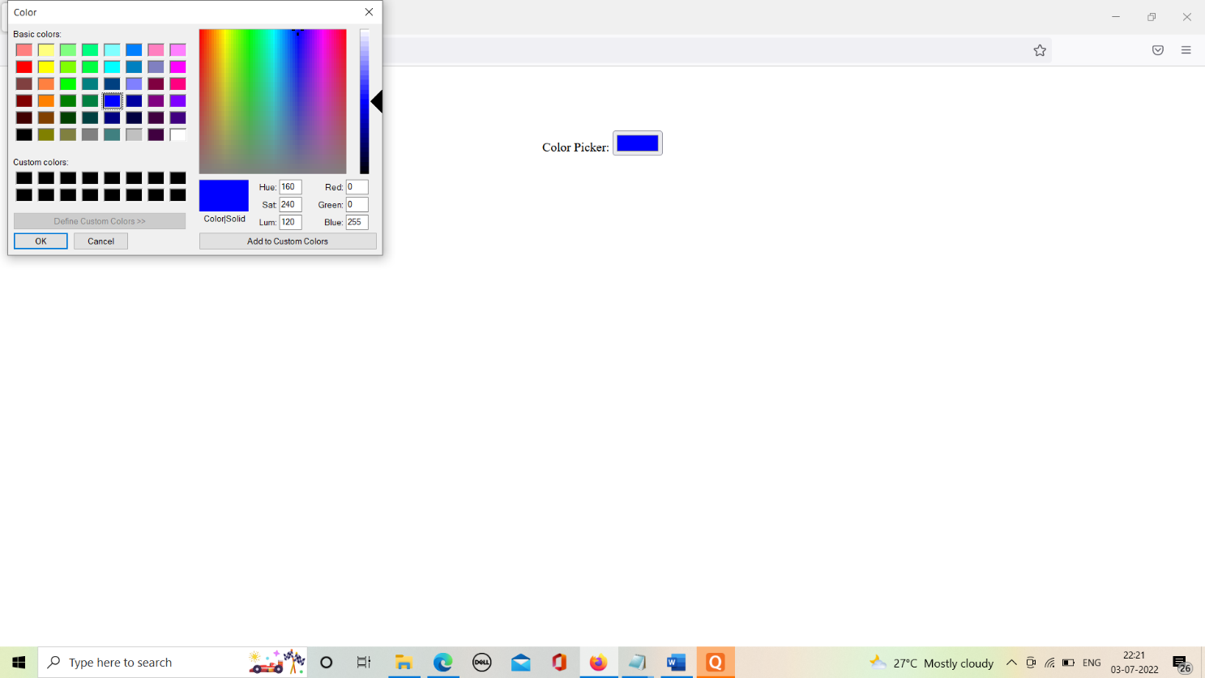

3.program for login/sign up form.

Source code:

First page:-

<html>

<center>

<a href="file:///C:/Users/DELL/Downloads/1.htm" target=" blank">

<img src="https://th.bing.com/th/id/OIP.PQ_8i-Dy5ceC9JG63dMHwQHaHa?pid=ImgDet&w=626&h=626&rs=1">

</a>

</center>

</html>

Login :-

<htm>

<head>

<title>login</title>

</head>

<center>

<body>

<a href="file:///C:/Users/DELL/Downloads/1.htm">Login </a>

<a href="file:///C:/Users/DELL/Downloads/2.htm">SignUp </a>

<a href="file:///C:/oops/p2/3.htm">Track Your Order</a>

<h1>login</h1>

<form>

<table style="width:100%">

<label for="fname"> Username:</label>

<input type="text" id="fname" name="fname"><br><br>

<label for="pass">Password: </label>

<input type="password" id="pass" name="pass"><br><br>

<button>submit</button>

</form>

</body>

</center>

</html>

Signup:-

<htm>

<head>

<title>signup</title>

</head>

<center>

<body>

<a href="file:///C:/Users/DELL/Downloads/1.htm">Login </a>

<a href="file:///C:/Users/DELL/Downloads/2.htm">SignUp </a>

<a href="file:///C:/oops/p2/3.htm">Track Your Order</a>

<h1>SIGN UP!</h1>

<form>

<table style="width:100%">

<label for="fname"> Username:</label>

<input type="text" id="fname" name="fname"><br><br>

<label for="pass">Password: </label>

<input type="password" id="pass" name="pass"><br><br>

<label for="rb">Gender: </label>

<label for="rb">Male </label>

<input type="radio" id="rb" name="Male">

<label for="rb">Female </label>

<input type="radio" id="rb" name="Female"><br><br>

<label for="dob">DOB:</label>

<input type="date" id="'dob" name="DOB"><br><br>

<label for="no"> Phone number:</label>

<input type="text" id="no" name="Phonenumber"><br><br>

<label for="mail"> Gmail :</label>

<input type="email" id="mail" name="mail"><br><br>

<label for="lk"> Languages known:</label>

<label for="lk"> English:</label>

<input type="checkbox" id="lk" name="english">

<label for="lk"> Hindi:</label>

<input type="checkbox" id="lk" name="hindi">

<label for="lk"> French:</label>

<input type="checkbox" id="lk" name="french"><br><br>

<label for="p"> Profile pic:</label>

<input type="file" id="p" name="profile"><br><br>

<input type="button" id="p" name="register" value="register">&nbsp;&nbsp;&nbsp;

<input type="button" id="p" name="reset" value="reset"><br><br>

</form>

</body>

</center>

</htm>

Tracking:-

<html>

<head><title>track</title></head>

<center>

<body>

<a href="file:///C:/Users/DELL/Downloads/1.htm">Login </a>

<a href="file:///C:/Users/DELL/Downloads/2.htm">SignUp </a>

<a href="file:///C:/oops/p2/3.htm">Track Your Order</a>

<h1>Track Your Order</h1>

<br><br><br>

<h2>Rate your shooping experience:</h2>

<label for="file">delivery of product on time:</label>

<progress id="file" value="50" max="100"> 60% </progress><br><br>

<label for="file">product quality:</label>

<progress id="file" value="60" max="100"> 60% </progress><br><br>

<label for="file">how friendly the site is:</label>

<progress id="file" value="50" max="100"> 60% </progress><br><br>

<label for="file">were you able to find the product which you were looking for?:</label>

<progress id="file" value="40" max="100"> 60% </progress>

</body>

</center>

</html>

Output:

